CENTRE OF DEVELOPMENT OF ADVANCED COMPUTING, MOHALI



Advanced course on Data Science and Analytics
(HPKVN)

Project Report
On
Building ML Model to Predict Turnover of the company.

Submitted to:- Submitted by:-
Mr. Sanjay Madan Rishabh Gaur
Shivani Chauhan
Vinayak Saini

Abstract

In this project, we were asked to experiment with a real world dataset, and to explore how machine learning algorithms can be used to predict the turnover of a company from the data. We were expected to gain experience using libraries like Numpy,Pandas,Matplotlib,Seaborn,Scikit Learn, and were expected to submit a report about the dataset and the algorithms used. After performing the required tasks on a dataset of our choice, herein lies our final report.

Keywords: Machine Learning, Regression, Supervised learning.

Content
- Introduction
- About Dataset
- About Company
- Glossary
- Project Objectives
- Designing turnover Prediction Workflow
- Methodology
- Libraries used
- Models used
- Workflow Diagram
- Visualization
- Conclusion

Introduction

Machine learning is a sub-domain of computer science which evolved from the study of pattern recognition in data, and also from the computational learning theory in artificial intelligence. It is the first-class ticket to most interesting careers in data analytics today. As data sources proliferate along with the computing power to process them, going straight to the data is one of the most straightforward ways to quickly gain insights and make predictions.

Machine Learning can be thought of as the study of a list of sub-problems, viz: decision making, clustering, classification, forecasting, deep-learning, inductive logic programming, support vector machines, reinforcement learning, similarity and metric learning, genetic algorithms, sparse dictionary learning, etc. Supervised learning, or classification is the machine learning task of inferring a function from a labeled data. In Supervised learning, we have a training set, and a test set. The training and test set consists of a set of examples consisting of input and output vectors, and the goal of the supervised learning algorithm is to infer a function that maps the input vector to the output vector with minimal error. In an optimal scenario, a model trained on a set of examples will classify an unseen example in a correct fashion, which requires the model to generalize from the training set in a reasonable way. In layman’s terms, supervised learning can be termed as the process of concept learning, where a brain is exposed to a set of inputs and result vectors and the brain learns the concept that relates said inputs to outputs. A wide array of supervised machine learning algorithms are available to the machine learning enthusiast, for example Neural Networks, Decision Trees, Support Vector Machines, Random Forest, Naïve Bayes Classifier, Bayes Net, Majority Classifier etc., and they each have their own merits and demerits. There is no single algorithm that works for all cases, as merited by the No free lunch theorem . In this project, we try and predict turnover in a dataset ,
which is the price history and trading volumes of the HERO MOTOCORP stock in the index NIFTY 50 from NSE (National Stock Exchange) India.
The dataset is at day-level with pricing and trading values split across the .csv file for the stock. The data spans from 1st January, 2000 to 30th April, 2021.

Problems and Issues in Supervised learning:

Before we get started, we must know about how to pick a good machine learning algorithm for the given dataset. To intelligently pick an algorithm to use for a supervised learning task, we must consider the following factors :

1. Heterogeneity of Data:
Many algorithms like neural networks and support vector machines like their feature vectors to be homogeneous numeric and normalized. The algorithms that employ distance metrics are very sensitive to this, and hence if the data is heterogeneous, these methods should be the afterthought. Decision Trees can handle heterogeneous data very easily.

2. Redundancy of Data:
If the data contains redundant information, i.e. contain highly correlated values, then it’s useless to use distance based methods because of numerical instability. In this case, some sort of Regularization can be employed to the data to prevent this situation.

3. Dependent Features:
If there is some dependence between the feature vectors, then algorithms that monitor complex interactions like Neural Networks and Decision Trees fare better than other algorithms.

4. Bias-Variance Tradeoff:
A learning algorithm is biased for a particular input x if, when trained on each of these data sets, it is systematically incorrect when predicting the correct output for x, whereas a learning algorithm has high variance for a particular input x if it predicts different output values when trained on different training sets. The prediction error of a learned classifier can be related to the sum of bias and variance of the learning algorithm, and neither can be high as they will make the prediction error to be high. A key feature of machine learning algorithms is that they are able to tune the balance between bias and variance automatically, or by manual tuning using bias parameters, and using such algorithms will resolve this situation.

5. Curse of Dimensionality:
If the problem has an input space that has a large number of dimensions, and the problem only depends on a subspace of the input space with small dimensions, the machine learning algorithm can be confused by the huge number of dimensions and hence the variance of the algorithm can be high. In practice, if the data scientist can manually remove irrelevant features from the input data, this is likely to improve the accuracy of the learned function. In addition, there are many algorithms for feature selection that seek to identify the relevant features and discard the irrelevant ones, for instance Principle Component Analysis for unsupervised learning. This reduces the dimensionality.

6. Overfitting:
The programmer should know that there is a possibility that the output values may constitute an inherent noise which is the result of human or sensor errors. In this case, the algorithm must not attempt to infer the function that exactly matches all the data. Being too careful in fitting the data can cause overfitting, after which the model will answer perfectly for all training examples but will have a very high error for unseen samples. A practical way of preventing this is stopping the learning process prematurely, as well as applying filters to the data in the pre-learning phase to remove noises.

Only after considering all these factors can we pick a supervised learning algorithm that works for the dataset we are working on. For example, if we were working with a dataset consisting of heterogeneous data, then decision trees would fare better than other algorithms. If the input space of the dataset we were working on had 1000 dimensions, then it’s better to first perform PCA on the data before using a supervised learning algorithm on it.

Dataset:
The dataset used is the price history and trading volumes of the HERO MOTOCORP stock in the index NIFTY 50 from NSE (National Stock Exchange) India.
The dataset is at day-level with pricing and trading values split across the .csv file for the stock. The data spans from 1st January, 2000 to 30th April, 2021 and has the following features:

1. Date
2. Symbol
3. Series
4. Prev Close
5. Open
6. High
7. Low
8. Last
9. Close
10. VWAP
11. Volume
12. Turnover
13. Trades
14. Deliverable Volume.
15. %Deliverable

Out of the features mentioned above, Date, Symbol, Series and Trades were excluded from building the model as these were redundant features.
Furthermore, the first three were in string form and were not numerical values, whereas Trades was excluded owing to a large number of null values in its column.
The process of excluding redundant features so that we can build an efficient model is called feature selection.

About Dataset
Context
Stock market data is widely analyzed for educational, business and personal interests.
Content
The data is the price history and trading volumes of the BAJAJ-AUTO stock in the index NIFTY 50 from NSE (National Stock Exchange) India. The dataset is at day-level with pricing and trading values split across the .cvs file for the stock. The data spans from 1st January, 2000 to 30th April, 2021..
Source
NSE India: https://www.nseindia.com/
Inspiration
Various machine learning techniques can be applied and explored to stock market data, especially for trading algorithms.

Mirror - Kaggle
Size - 619 kb , Rows - 5306 , Columns - 15
Null Values are present in the Dataset.

About Company

A GLOBAL CORPORATE. A GLOBAL BRAND.
With innovation at the core of its philosophy, the New Delhi (India) headquartered Hero MotoCorp has been at the forefront of designing and developing technologically advanced motorcycles and scooters for customers around the world. It became the world's largest two-wheeler manufacturer in 2001, in terms of unit volume sales in a calendar year, and has maintained the coveted title for the past 20 consecutive years.
With over 100 million satisfied customers across the globe, it continues to champion socio-economic progress and empowerment through its range of products and services.
Led by Dr. Pawan Munjal, Chairman, Hero MotoCorp, it has taken rapid strides to expand its presence to 40 countries across Asia, Africa, and South & Central America. Hero MotoCorp is a truly global enterprise with a workforce that comprises people from different nationalities including India, Bangladesh, Colombia, Germany, Austria, Japan and France.
Hero MotoCorp is the dominant market leader in India – the world's largest two-wheeler market – with over 50% share in the domestic motorcycle market.
GLOSSARY

INTRADAY CHART:-
This type of chart shows an investment's price movements and trading volume within a given trading day -- typically between 9:30 a.m. to 4 p.m. Eastern time. Because of their narrow time window and high level of detail, intraday charts typically cater to traders looking for short-term price trends.

VWAP:-
The volume-weighted average price (VWAP) is a technical analysis indicator used on intraday charts that resets at the start of every new trading session.
It's a trading benchmark that represents the average price a security has traded at throughout the day, based on both volume and price.

Series EQ:-
EQ: It stands for Equity. In this series intraday trading is possible in addition to delivery. BE: It stands for Book Entry. Shares falling in the Trade-to-Trade or T-segment are traded in this series and no intraday is allowed. This means trades can only be settled by accepting or giving the delivery of shares.

Volume:-
Volume in the stock market means the total number of shares traded in a specified time frame. This would include every share that is bought and sold during the time period in review.

Deliverable:-
Deliverable quantity or Deliverable Volume is the quantity of shares which actually move from one set of people (who had those shares in their demat account before today and are selling today) to another set of people (who have purchased those shares and will get those shares by T+2 days in their demat account).

Symbol:-
A stock symbol is an arrangement of characters—usually letters—representing publicly-traded securities on an exchange. When a company issues securities to the public marketplace, it selects an available symbol for its shares, often related to the company name. Investors and traders use the symbol to place trade orders.

Previous Close:-
Previous close almost always refers to the prior day's final price of a security when the market officially closes for the day. It can apply to a stock, bond, commodity, futures or option contract, market index, or any other security.

Open:-
It is the price at which the financial security opens in the market when trading begins. It may or may not be different from the previous day's closing price. The security may open at a higher price than the closing price due to excess demand of the security.

High:-
Today's high refers to a security's intraday highest trading price. It is represented by the highest point on a day's stock chart. This can be contrasted with today's low, which is the trading day's intraday low price.

Low:-
Low is the lowest price that a stock trades on that day. It can be difficult to predict a stock's intraday low.

Last:-
The last price is the one at which the most recent transaction occurs, while the market price is whatever price the brokerage can find to fulfill your order as soon as possible. If you're buying a stock, then the market price is the ask price at that moment.

Close:-
The close is a reference to the end of a trading session in the financial markets when the markets close for the day. The close can also refer to the process of exiting a trade or the final procedure in a financial transaction in which contract documents are signed and recorded.

Turnover:-
The amount of money taken by a business in a particular period.

%Deliverable:-
Deliverable quantity represents that portion of overall traded volume in which an investor has taken the delivery into a demat account or sold from a demat account. The remaining quantity are intraday transactions, in which no delivery is made or received.
Deliverable %=Volume/Deliverable Volume*100

Intraday:-
Intraday trading means buying and selling stocks on the same trading day. Intraday trading is also known as Day Trading. Share prices keep fluctuating throughout the day, and intraday traders try to draw profits from these price movements by buying and selling shares during the same trading day.

For example, a trader buys a stock XYZ for Rs 100 at 9:25 AM and sells XYZ for Rs 102 at 12:45 PM. The intraday profit will be 2 percent.

NSE:- National Stock Exchange Of India.

Project Objectives

- To extract useful insights from data.
- To build a ML model to predict turnover of the company.
- Predicting 3 Turnover Cases for the Company namely - Base Case , Worst case , Best Case.
- Building a Dashboard for the company to gain Useful Insights.

Designing Turnover Prediction Workflow

The overall scope to build an ML-powered application to predict Turnover is generic to standardized ML project structure that includes the following steps:

- Defining problem and goal:- It’s essential to understand what insights you need to get from the analysis and prediction. Understand the problem and collect requirements, stakeholder pain points, and expectations.

- Establishing data source:- Next, specify data sources that will be necessary for the modeling stage.

- Data preparation, exploration, and preprocessing:- Raw historical data for solving the problem and building predictive models needs to be transformed into a format suitable for machine learning algorithms. This step can also improve overall results by increasing the quality of data.

- Modeling and testing:- This covers the development and performance validation of turnover prediction models with various machine learning algorithms.

- Deployment and monitoring:- This is the last stage in applying machine learning for turnover prediction. Here, the most suitable model is sent into production.
Methodology

- We took the stock market data of the company and did pre-processing on it.
- Afterwards we took the processed data and split it into two variables x and y which were further used for creating training and testing dataset.
- After the creation of the training and testing dataset, we started building machine learning models through regression models. The data splitting ratio was kept at 70:30.
- We checked the accuracy of all the models via cross validation score(MSE) and chose the best performing model for the deployment of our model which turned out to be the GradientBoosting algorithm.
- We used the GridsearchCV module for refining the GradientBoosting model through hyper tuning.
- As the GradientBoosting algorithm was the best performing model with an accuracy of 99%, it was deployed to predict the turnover of the company for custom cases namely Base case, Best case, Worst case.

Libraries Used

- NumPy

NumPy is the fundamental package for scientific computing in Python. It is a Python library that provides a multidimensional array object, various derived objects (such as masked arrays and matrices), and an assortment of routines for fast operations on arrays, including mathematical, logical, shape manipulation, sorting, selecting, I/O, discrete Fourier transforms, basic linear algebra, basic statistical operations, random simulation and much more.

- Pandas


pandas is an open source, BSD-licensed library providing high-performance, easy-to-use data structures and data analysis tools for the Python programming language.
- Matplotlib


Matplotlib is a comprehensive library for creating static, animated, and interactive visualizations in Python. Matplotlib makes easy things easy and hard things possible.

- Seaborn



Seaborn is a Python data visualization library based on matplotlib. It provides a high-level interface for drawing attractive and informative statistical graphics.

- Scikit-Learn

- Sklearn.Metrics
The sklearn.metrics module implements functions assessing prediction error for specific purposes. It implements several loss, score, and utility functions to measure regression performance. Some of those have been enhanced to handle the multi output case: mean_squared_error, mean_absolute_error, r2_score.

- Mean Squared Error -

The mean_absolute_error function computes mean absolute error, a risk metric corresponding to the expected value of the absolute error loss.

- R2 Score -

The r2_score function computes the coefficient of determination, usually denoted as R².

It represents the proportion of variance (of y) that has been explained by the independent variables in the model. It provides an indication of goodness of fit and therefore a measure of how well unseen samples are likely to be predicted by the model, through the proportion of explained variance.

TOOLS USED:-


Power BI is an interactive data visualization software product developed by Microsoft with a primary focus on business intelligence.^{[1]} It is part of the Microsoft Power Platform. Power BI is a collection of software services, apps, and connectors that work together to turn unrelated sources of data into coherent, visually immersive, and interactive insights. Data may be input by reading directly from a database, webpage, or structured files such as spreadsheets, CSV, XML, and JSON.


Jupyter Notebook (formerly IPython Notebooks) is a web-based interactive computational environment for creating notebook documents.
A Jupyter Notebook document is a browser-based REPL containing an ordered list of input/output cells which can contain code, text (using Markdown), mathematics, plots and rich media. Underneath the interface, a notebook is a JSON document, following a versioned schema, usually ending with the ".ipynb" extension.

MODELS USED

- Linear Regression , Lasso, Elastic Net, DecisionTreeRegressor, KNeighborsRegressor, GradientBoostingRegressor.

- Sklearn.Linear_Model
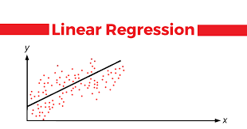

Linear Regression Linear Regression is a machine learning algorithm based on supervised learning. It performs a regression task. Regression models a target prediction value based on independent variables. It is mostly used for finding out the relationship between variables and forecasting.

- Sklearn.Linear_Model.Lasso

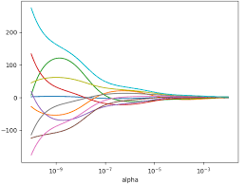

Lasso regression is a machine learning algorithm that can be used to perform linear regression while also reducing the number of features used in the model. Lasso stands for least absolute shrinkage and selection operator. Pay attention to the words, “least absolute shrinkage” and “selection”.

- Sklearn.Linear_Model.ElasticNet

The elastic net is a regularized regression method that linearly combines the L₁ and L₂ penalties of the lasso and ridge methods.

The benefits of elastic net is that it allows a balance of both penalties, which can result in better performance than a model with either one or the other penalty on some problems. Another hyperparameter is provided called “lambda” that controls the weighting of the sum of both penalties to the loss function.

- Sklearn.tree
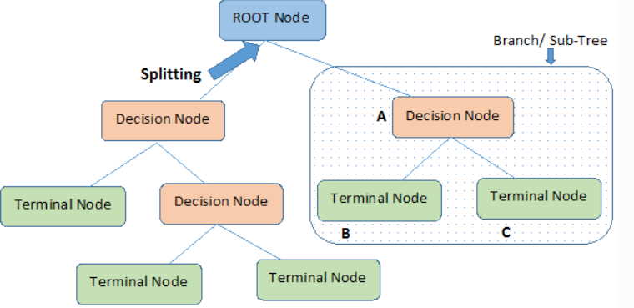

Decision trees regression normally uses mean squared error (MSE) to decide to split a node in two or more sub-nodes. Suppose we are doing a binary tree the algorithm first will pick a value, and split the data into two subset. For each subset, it will calculate the MSE separately.

Sklearn.neighbors.KNeighborsRegressor

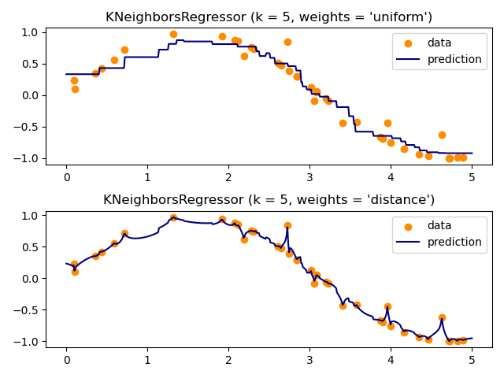

Neighbors-based regression can be used in cases where the data labels are continuous rather than discrete variables. The label assigned to a query point is computed based on the mean of the labels of its nearest neighbors.
scikit-learn implements two different neighbors regressors: KNeighborsRegressor implements learning based on the k nearest neighbors of each query point, where k is an integer value specified by the user. RadiusNeighborsRegressor implements learning based on the neighbors within a fixed radius ‘r’ of the query point, where ‘R’ is a floating-point value specified by the user.
- Sklearn.ensemble.GradientBoostingRegressor

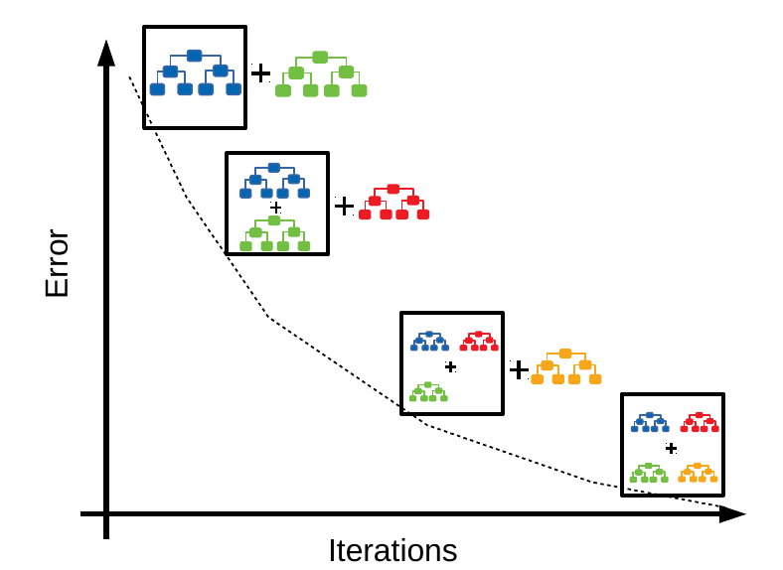

Gradient Boosting for regression.
GB builds an additive model in a forward stage-wise fashion; it allows for the optimization of arbitrary differentiable loss functions. In each stage a regression tree is fit on the negative gradient of the given loss function.
GradientBoostingRegressor supports a number of different loss functions for regression which can be specified via the argument loss; the default loss function for regression is squared error ('squared_error').
WORKFLOW DIAGRAM

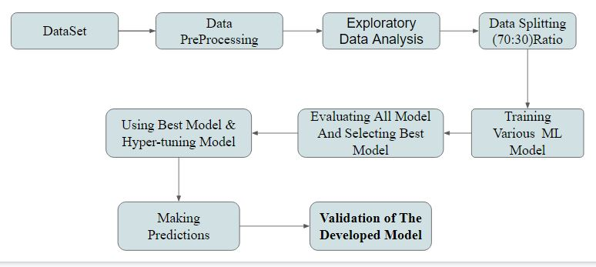

Following is the whole process:-

1. Pandas,Numpy and Matplotlib were imported for data pre-processing and for plotting graphs.
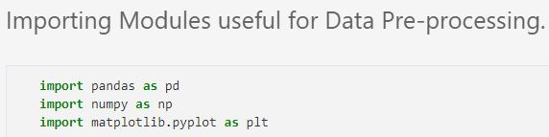

2. The dataset was loaded into the dataframe.
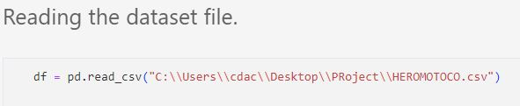

3. To know the details about the dataset we looked at the summary of the data with the help of df.tail(), df.info(), df.describe() functions.

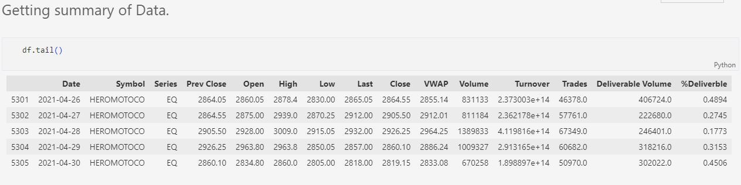
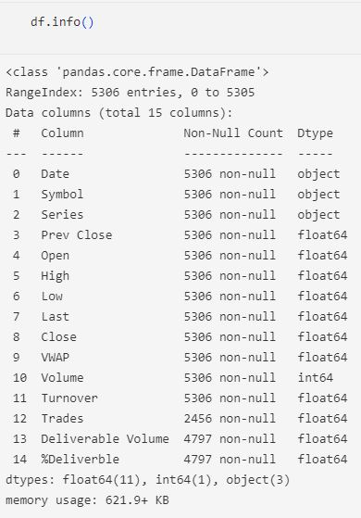
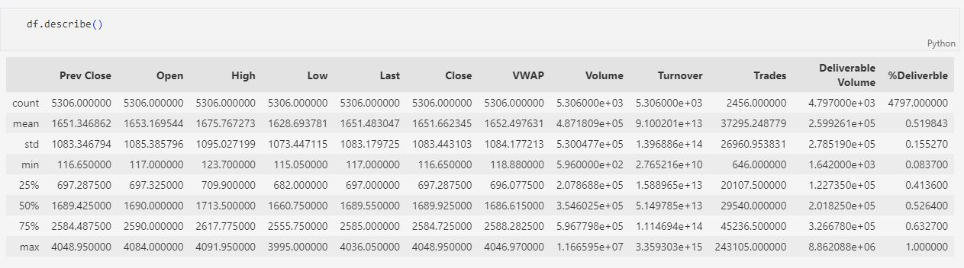
4. We Checked for null values in suspected columns to further go and perform feature selection.
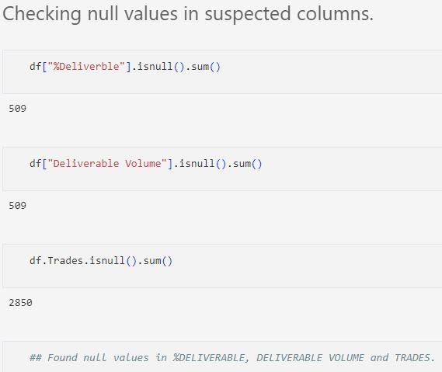

5. We checked the data for skewness.
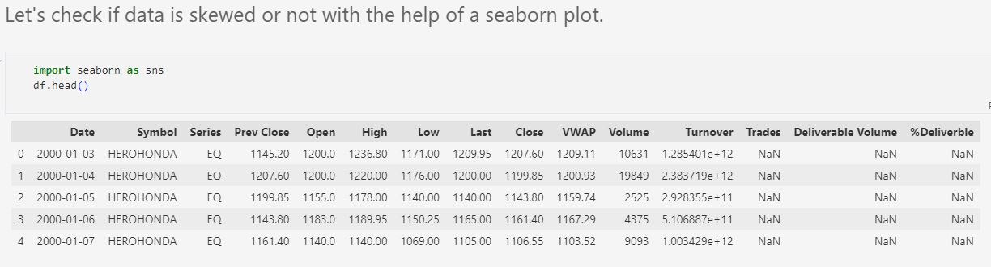
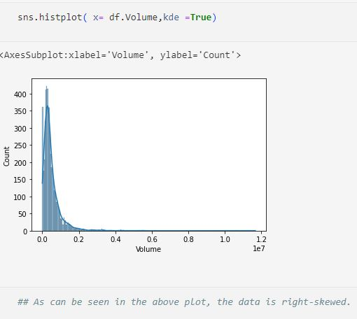

- We dropped the Trades column as it has too many Null values.

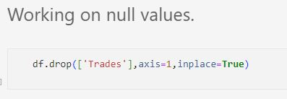

- We replaced the null values in the Deliverable Volume and %Deliverable column with the median value of the data in those respective columns.

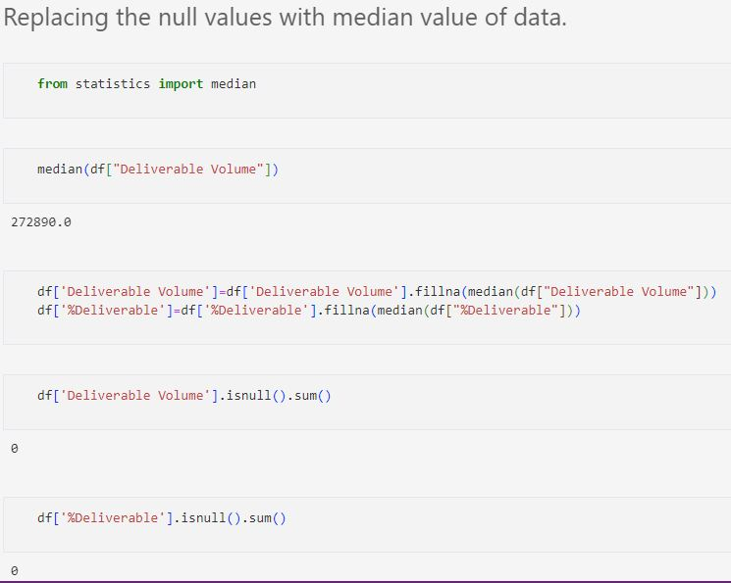

- Prepared our input and output for the ML Model.
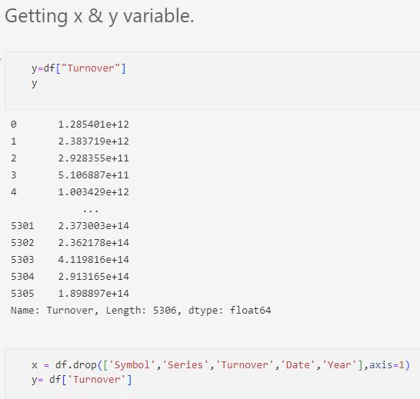

- Splitted the data into a 70:30 ratio.
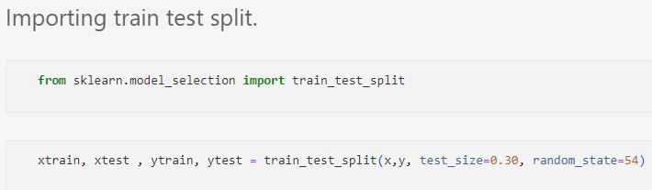
70% into Training and 30% into testing of Model

- Using Simple Linear Regression, predicting Turnover with ML ModelScore.
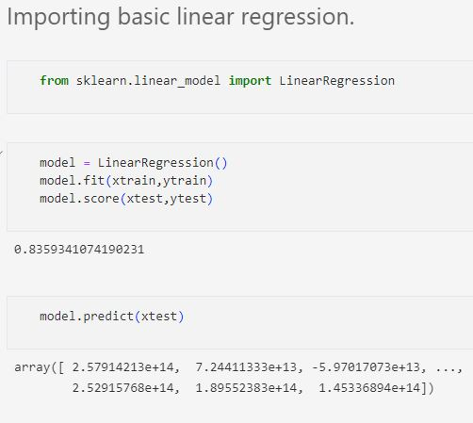

- Imported Other ML Algorithms.
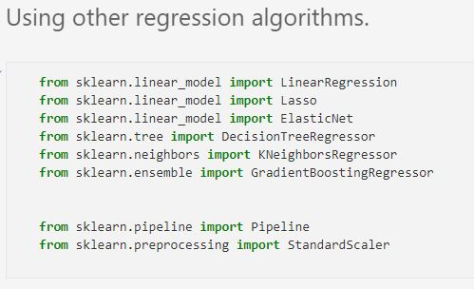

- Imported cross val score and Kfold.
Provides train/test indices to split data in train/test sets. Split the dataset into k consecutive folds (without shuffling by default).Each fold is then used once as a validation while the k - 1 remaining folds form the training set.
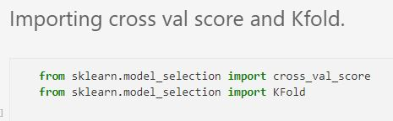

- We shortened the value of the output variable by using np.log2()function so as to enable easy calculation of values.

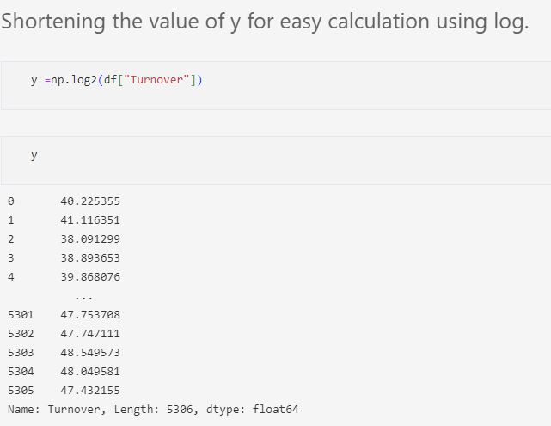

- Using pipelines to shorten the process of converting input into standard scaler and fitting transformed values into ML Model.

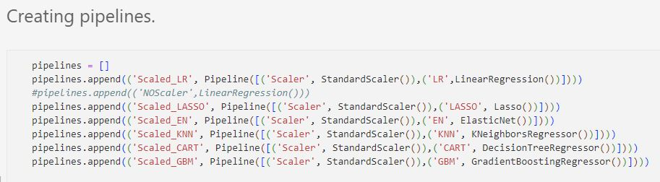
.
15. Using a for loop to evaluate all models’ Negative Mean Squared Error.
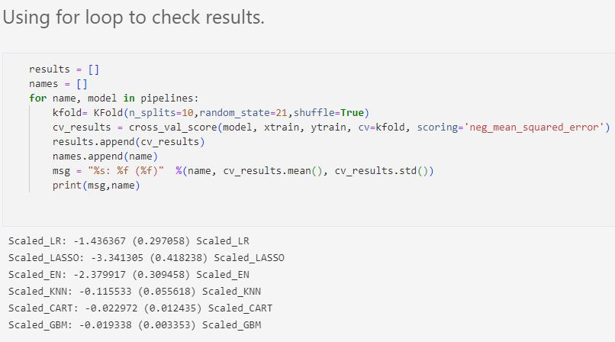

16. Selected Gradient Boosting And HyperTuned with GridsearchCV to Get Best Results.
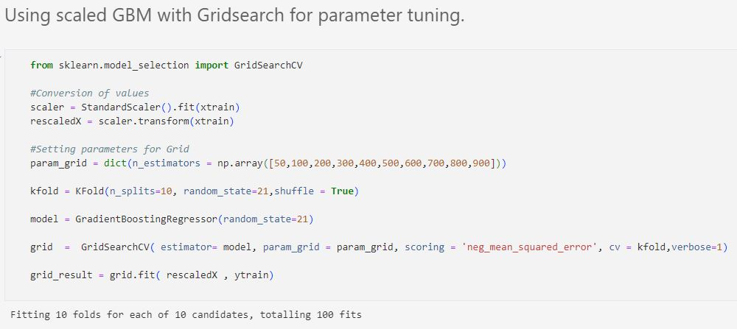

17. Found minimum error at estimator of 900 Which will be used for our Gradient boosting model.
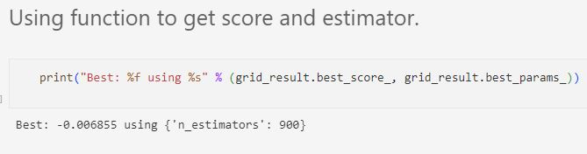

18. The mean squared error function computes mean square error, a risk metric corresponding to the expected value of the squared (quadratic) error or loss.
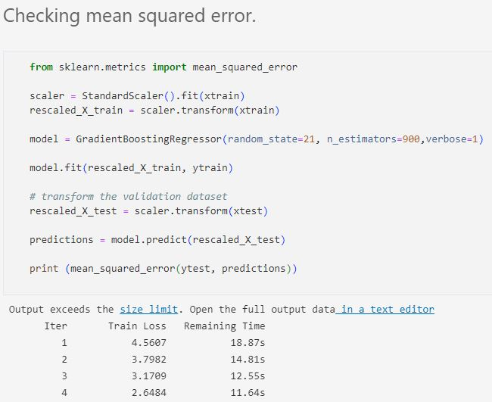

19. Predictions made by ML model in Log values.
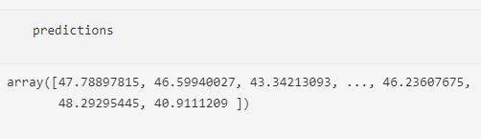

20. Validation.
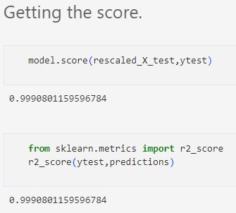

21. Predict custom cases, namely base case, best case and the worst case regarding the company's turnover. 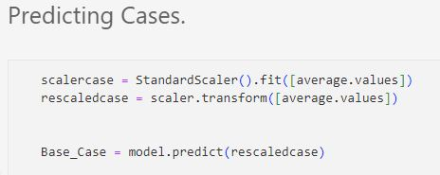
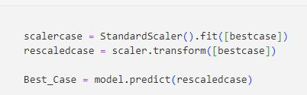

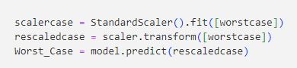

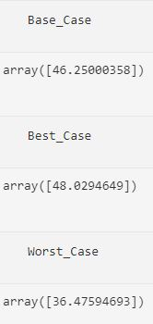

22. Plotting the bar graph for the values in the custom cases.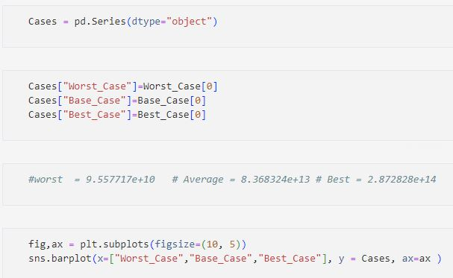

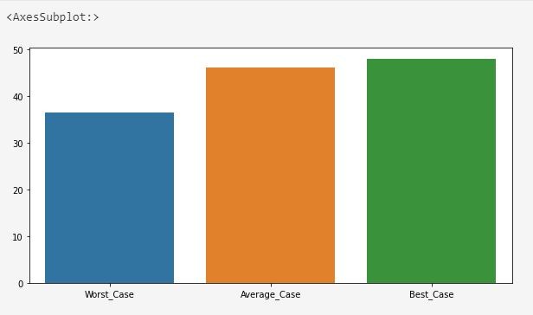

24. Values of the custom cases.

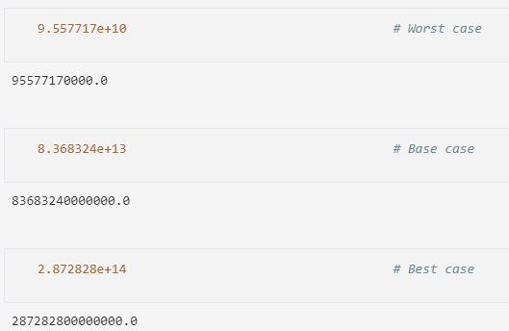

25. We converted the resulting values of the custom cases into currency format for easy understanding of the data.

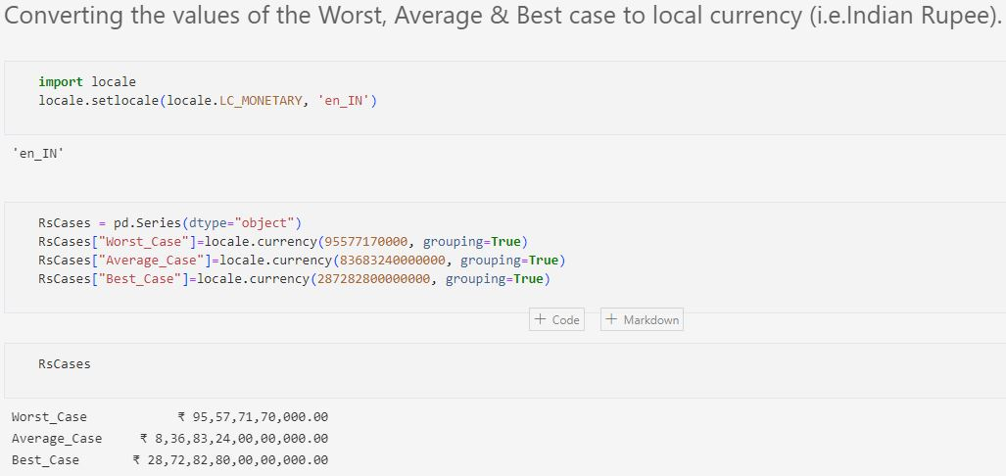

Visualizations

EDA:-

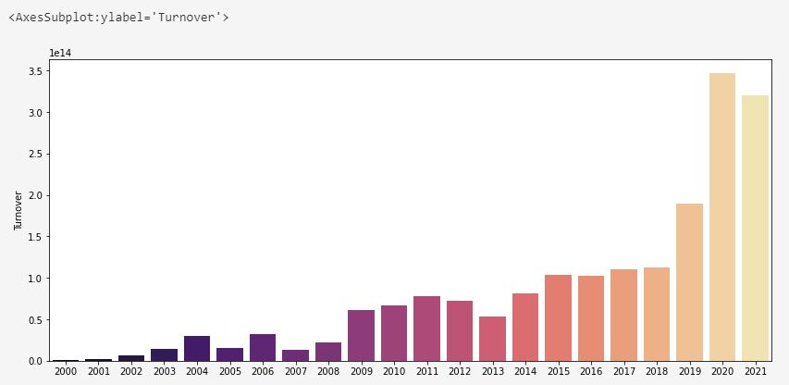
The above graph shows the relation between Turnover and Years. From this graph we can easily infer that the value of turnover was maximum in the year 2020 and minimum in the year 2000 which indicates significant growth of the company over the years.

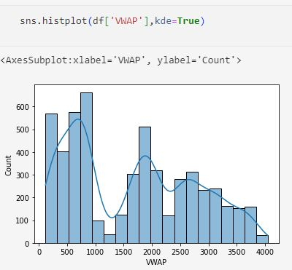
The above graph is a countplot made for showing the values of VWAP.

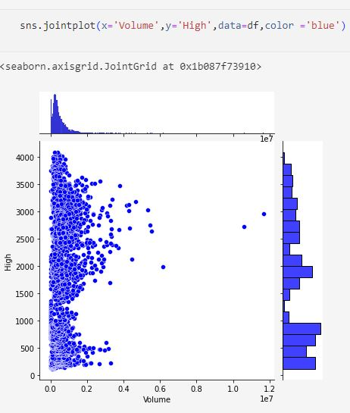

The above shown jointplot shows the relation between HIGH price and Volume of shares of the company that are traded each day in the stock market.

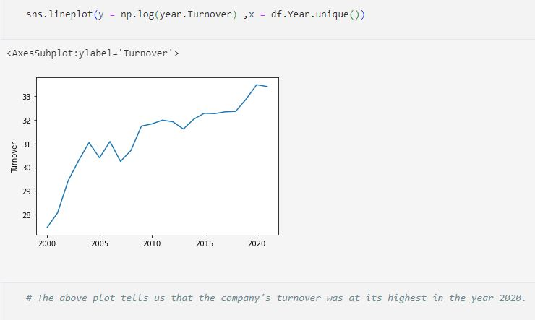

The above shown line plot shows us the trend of turnover over the years describing the rise and fall of turnover since the year 2000 upto the year 2021.

Here, we can clearly see that the value of turnover was minimum in the year 2000 and maximum in the year 2020.
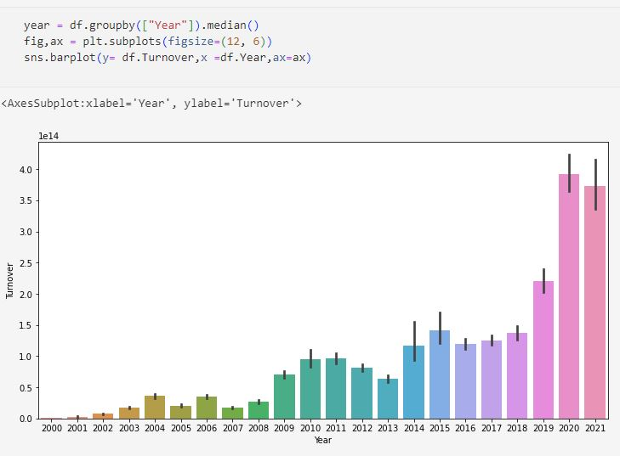

Here we have plotted the multivariate graph of turnover vs. year along with median being shown in the middle of each column for that respective year.

DASHBOARDS

1.
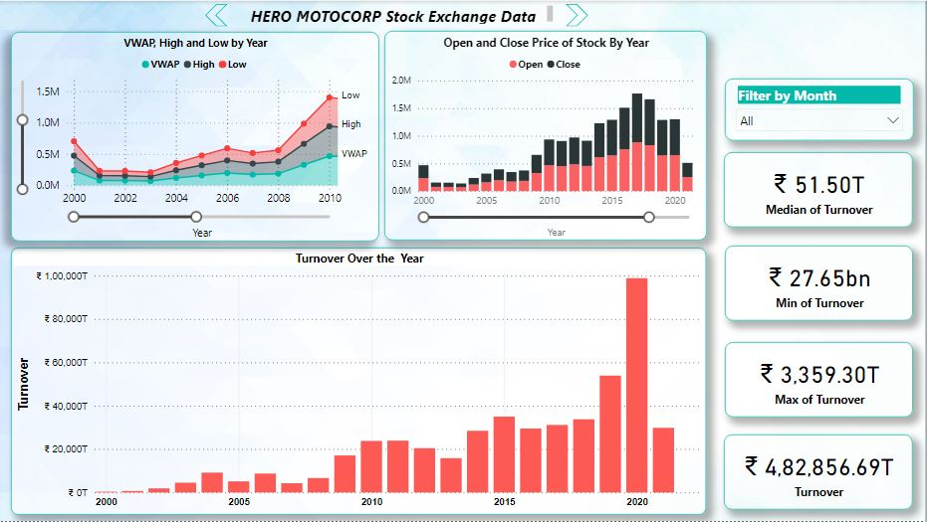

The above shown dashboard gives us:-
- An in-depth look at the various values of turnover , for eg. minimum value, maximum value, total turnover, median of turnover.
- the relation of VWAP, High and Low w.r.t Year.
- the relation of Open and Close price w.r.t Year.
- the progression of turnover over the years with a bar plot of Turnover vs. Years.

2.
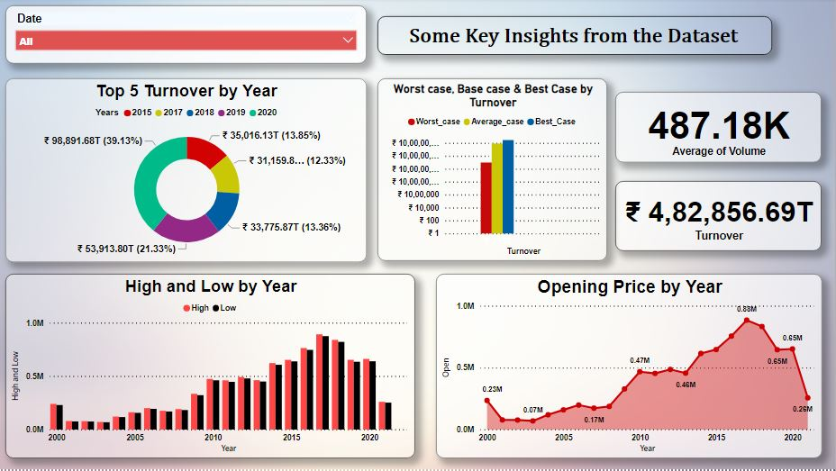

The above shown dashboard gives us some key insights about:-

- The top 5 years by the value of their turnover.
- The value of turnover for three custom cases i.e Base case, Best case, Worst case of the company.
- The values of high and low price w.r.t Year.
- The value of opening price w.r.t Year.
- The average value of volume.
- The value of annual turnover.

CONCLUSION

We found out that out of all ML models, Gradient Boosting turned out best for predicting Turnover when tuned with Gridsearch parameters with an Accuracy Score of 99%.

This ML Project is useful for Predicting Turnover with custom cases for the company.

Turnover cases values -:
Worst case - rs.95,57,71,70,000.00
Base case - rs.8,36,83,24,00,00,000.00
Best case - rs.28,72,82,80,00,00,000.00

